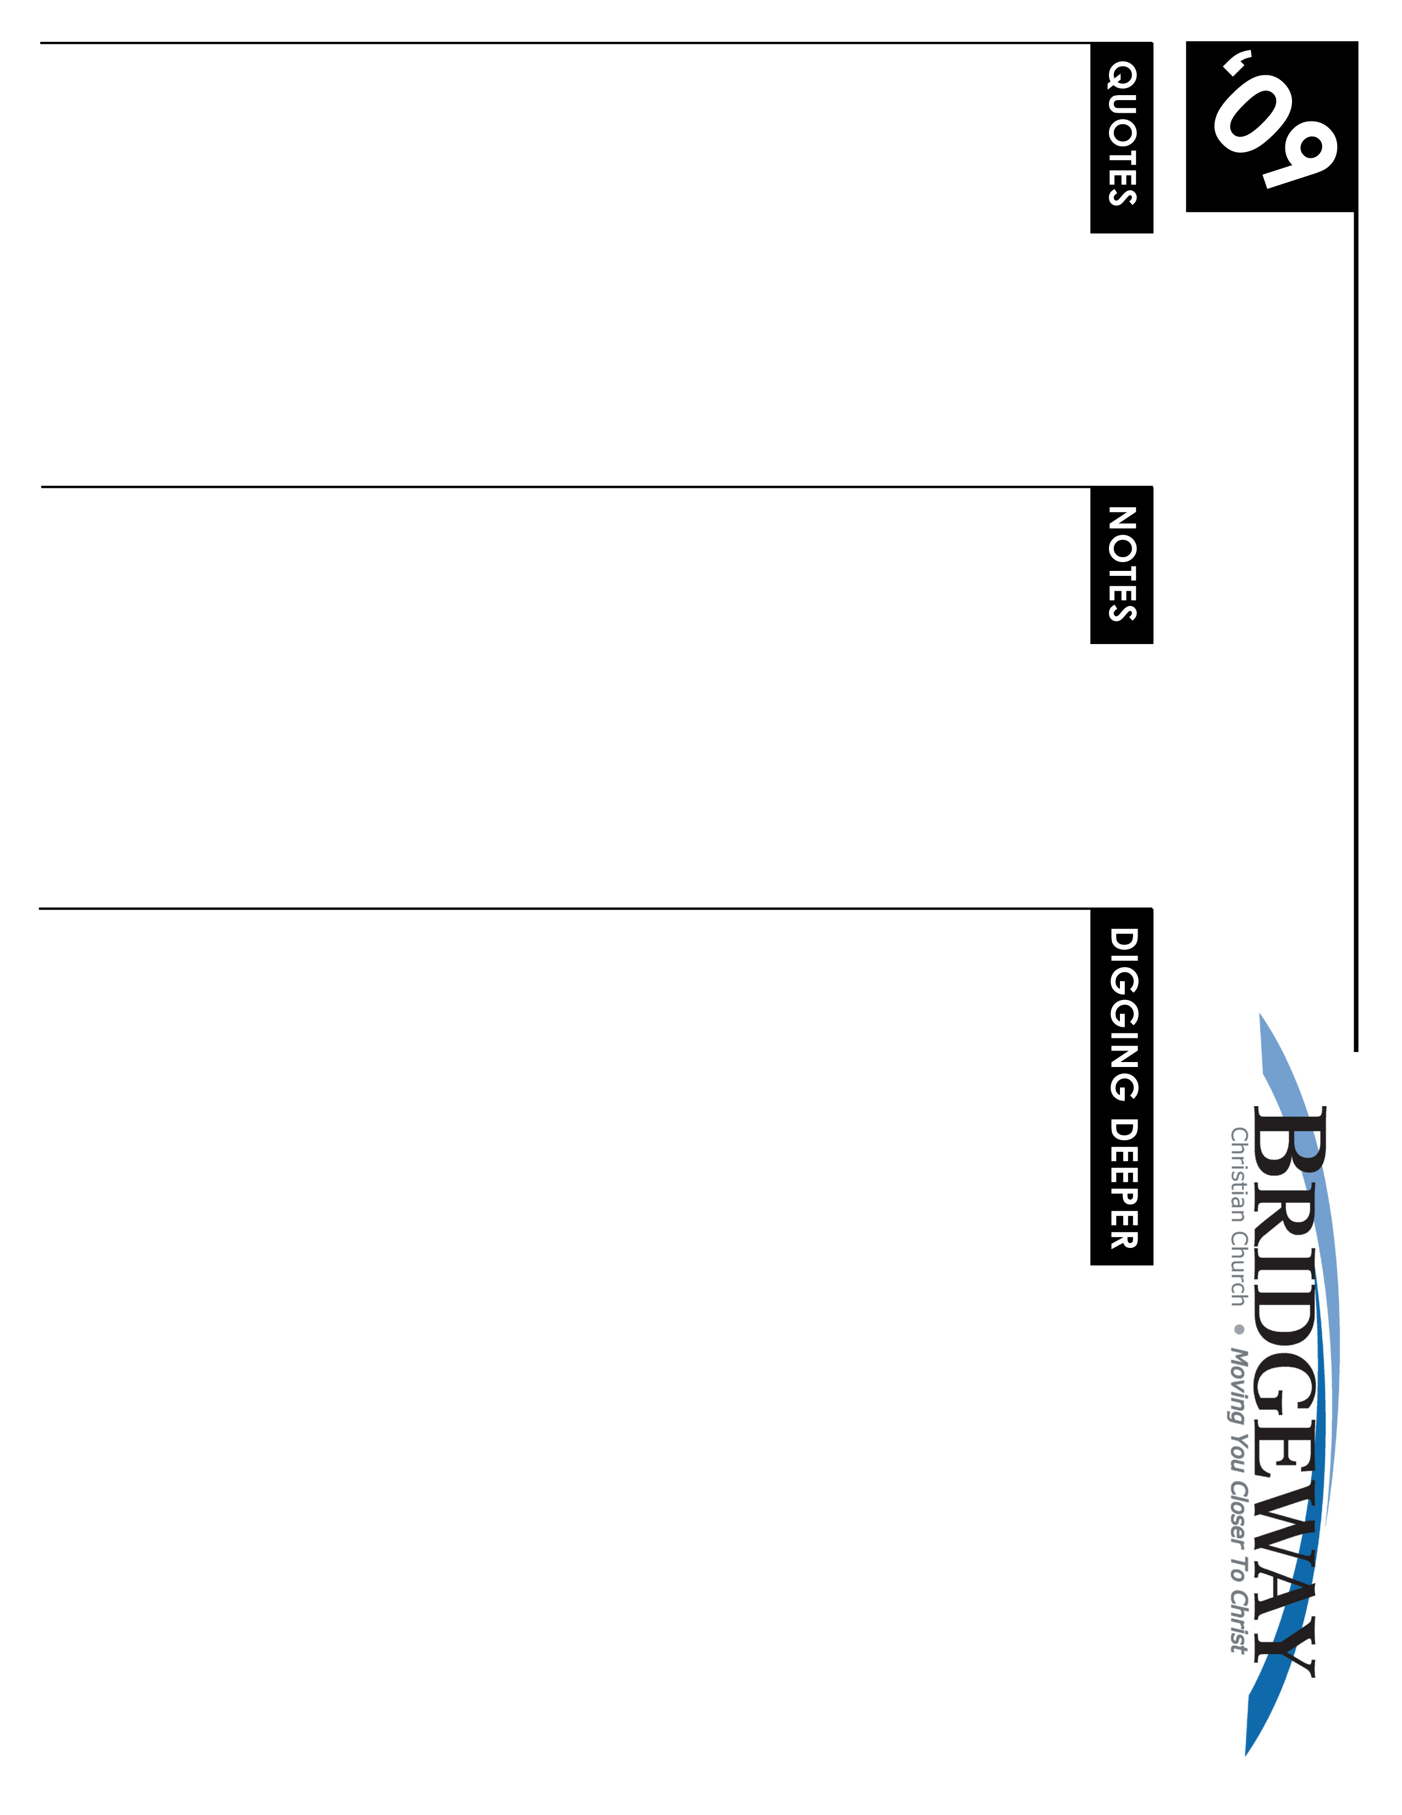
On the Brink - Revelation Series – Pt. 1
2/28/09-3/1/09 – Revelation 1:1-3
Writing From the Edge of Persecution

“Now I begin to be a disciple...Let fire and cross, flocks of beasts, broken bones, dismemberment,...come upon me, so long as I attain to Jesus Christ.”
Ignatius of Antioch, (martyred c. 107AD)

“A critical problem facing every writer on the book of Revelation grows out of the literary genre in which the book is cast. It is difficult to say what anything means until one has decided in a sense what everything means.” Robert Mounce, NICNT
The ___________ Message of the Book of ________________ is a Message of _______

Questions for the Heart and Spirit
- Do you believe that God reveals Himself to us? By what means? Why or Why not?
- In Rev 1:1 who is John, and how do you know that? Tell all you know about John.
- How do you define the word “revelation”? Check the dictionary.
- In the book of Revelation, who is the revealer? To whom is the message revealed?
Questions for the Mind
- Read: The introduction to the book of Revelation in the Bible Knowledge Commentary, or other commentary.
Why is it the last book in the New Testament? When was it written and under what conditions? Why is that important in understanding the book? What are the four generally accepted interpretation options? Where do you stand and why?
- Read: 2 Sam 7:18-29; Dan 8:15-27; Luke 2:25-32
What did God reveal to David, and how did He reveal it? What did God reveal to Daniel and how did he reveal it? What did God reveal to Simeon and how did He reveal it? How did he reveal his message to John in Rev 1:1?
- Read: Rev 1:1-3
What is the definition of ‘servant’ as used in these verses? Is there a difference between John`s testimony and that of Jesus? Why would one who reads the words be blessed the same as one who hears and takes it to heart? Do you think the blessings are equal?
- Read: Jude 14; Rev 1:3
How long have there been prophecies? Do they continue until today? Yes or no? Why?
- Look up the definitions for ‘show’, ‘soon’, and ‘near’ in the dictionary. Now look up the Greek words used in the Rev 1:1-3 text. How do the meanings of these words differ?
Application
- Think about how you can apply last week’s sermon to this weeks lesson. Does this give new importance to the Book of Revelation?
- Pray that God will reveal Himself to you through the study of Revelation in the coming weeks.
- Share with someone what you have learned from this study.
WHAT’S GOING ON
NEW TO BRIDGEWAY?
Welcome! We believe that you are here by God's direct invitation regardless of who invited you or how you found the church. And we believe that He brought you here to transform you. It's our goal to help make things clearer and to create an atmosphere of engagement with God and worship of the King of Kings! So, please, join us as we spend time with the Lord.

If you would like more information about Bridgeway, be sure to fill out the Welcome Cardin the seat pocket in front of you and drop it into the offering. We can send more info on who we are and how you can get involved.

Plus there’s always a ton of info on our website- including lessons, videos, announcements, and more! www.bridgewaychristian.org

INFORMATION

Kidsway Children’s Ministry is provided for all ages. Please visit the Welcome Center for more information and classroom locations.
CROWN FINANCIAL GROUPS
Sign-ups Start Jan. 24th in the lobby
The Biblical Financial Study is a 10-week study that teaches the successful combination of God’s wisdom along w/practical financial principles.
CHURCH OF THE WEEK w/LOVE INC.
March 16th – 21st Activities and ways to participate available soon. Contact Kim Turner for more details 916.223.2280

CONNECTIONS CLASS
Starts March 22nd at 9am in the Community Hall (new building). No registration needed.

MEMBERSHIP CLASS
May 3rd at 9:00am in the Community Hall (new building).

POPROCKS LAUNCH
Kidsway’s Poprocks will launch Wed. April 1st at 6:30pm.

JR HIGH WINTER CAMP - Feb. 27th – March 1st.
SR HIGH WINTER CAMP - Feb. 13th – Feb. 16th. Contact the Youth Dept. for details on how to sign up. 916.626.3050 ext. 231

NEXT NEWCOMERS DINNER
Friday March 20th at 6:30pm.

WOMEN’S SPRING RETREAT
April 24th – 26th. More details coming soon! Check out bridgewaychristian.org for the latest news!

SMALL GROUPS
Grow deeper with God & others…
Build a deeper relationship with God, experience significant growth in your spiritual life, and feel more a part of the church family - participate in a small group Bible study.

Pick up a Small Group Booklet in the lobby or check the church web site to see a list of groups.
FOR THE LATEST NEWS, EVENT DETAILS, MINISTRY INFO, SIGN-UPS, BLOGS, PODCASTS & MORE VISIT
www.BridgewayChristian.org
Bridgeway Christian Church, 3785 Placer Corporate Drive Suite 560, 95765, ph. (916) 626-3050
LIVEWIRE Jr. & Sr. High Ministry (6th – 12th grade) meets during all the services in the Youth Room

JR. HIGH’s THE EDGE (6th – 8th grade)
Every Wed. @ 6:30pm in the Youth Room

SR. HIGH’S REFUGE
Every Thurs. @ 7:00pm in the Youth Room

Crossroads young adult ministry
Meets every Sunday @ 6:00pm in the Sanctuary for dinner and worship together.

